EVAN BAESLER
SEPTEMBER 13 2026

EE Design 1 Technical Report
Power Supply Design

Introduction

In the Power Supply Design module, we are tasked with creating two voltage regulators, one utilizing an LM7805 linear regulator, and the second using an LM2576 adjustable switching regulator. Our goal is to create designs for both to output 5V with 5mA & 100mA output currents as options, and to record their characteristics in both simulation and practical application to determine the ideal use-case for either chip.
Methods

Starting our design, we start by designing the circuit in LTSpice to ensure correct operation and output. To model our circuit in LTSpice, we must begin by modeling our RIGOL 2702 power supply, which is done using an ideal voltage source to model our 120VAC output from the wall receptacle. This then goes to a 130:1 transformer, due to the relationship below:
$$\frac{V_{primary}}{V_{secondary}}=\sqrt{\frac{L_{1}}{L_{2}}}$$
We find that a ratio of 130:1 would give us a voltage output ratio from primary to secondary of 11.4:1, which means that our output is 120V/11.4V $≅$ 10.52V, which when accounting for our full-bridge rectification forcing current through 2 diodes, which drops the voltage by 0.7V per diode, gives us 10.52V – 1.4V = 9.12VAC.

This is followed by a bypass capacitor, which removes high-frequency noise from our input pin by shorting it to ground, and supplements the charge on the VIN pin to allow the IC to convert AC to DC. A 1000uF capacitor is a solid middle-ground of medium-large capacitors that are large enough to store significant charge without causing intense in-rush current upon activation.

On the output side for the LM2576 adjustable, we provide a Zener diode to utilize non-linear reverse breakdown, effectively providing a hard limit to the output voltage, releasing the excess to ground (TI 2026.) The inductor is important for a buck converter, to store energy and allow for voltage smoothing (Gemini/GPT). After this, we provide another bypass capacitor for noise reduction. The adjustable version of the LM2576 also requires in section 8.2 of the datasheet to provide two resistors in series, with the top node connecting to output, the middle to feedback, and the bottom to ground. Feedback forces a reference voltage of 1.23, and the output provides a voltage of:
$$V_{out}=V_{ref}*\left(1+\frac{R2}{R1}\right)$$

Schematics are shown below for the LM7805 (linear regulator), and LM2576 (switching regulator.)

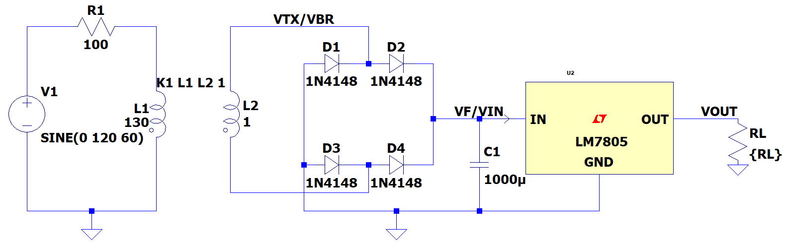
Figure 1: Linear Regulator LTSpice Schematic
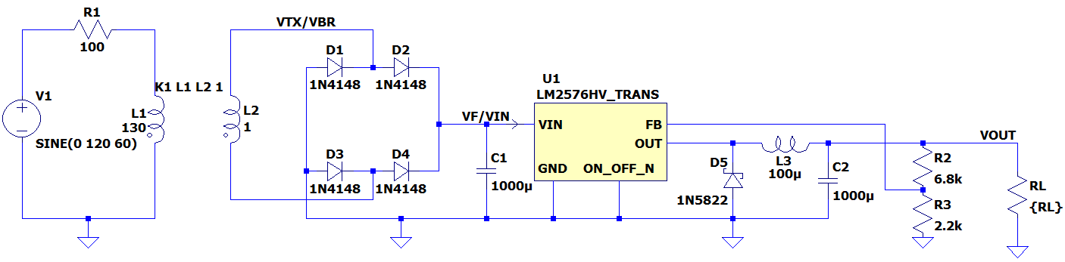
Figure 2: Switching Regulator LTSpice Schematic
The linear regulator
Results
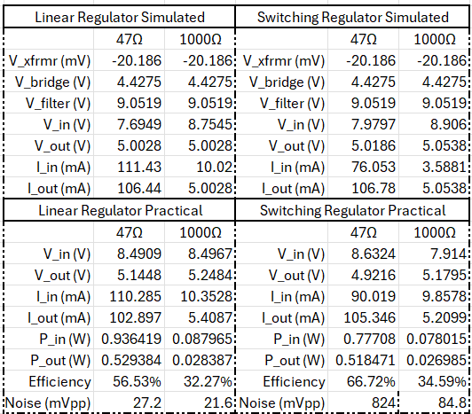
Figure 3: Simulation & Practical Data Measurements
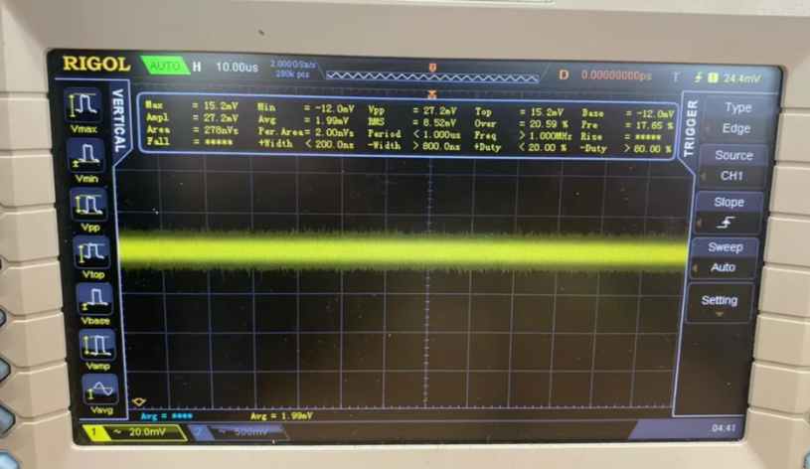
Figure 4: 47Ω Linear Regulator AC Coupling Oscilloscope
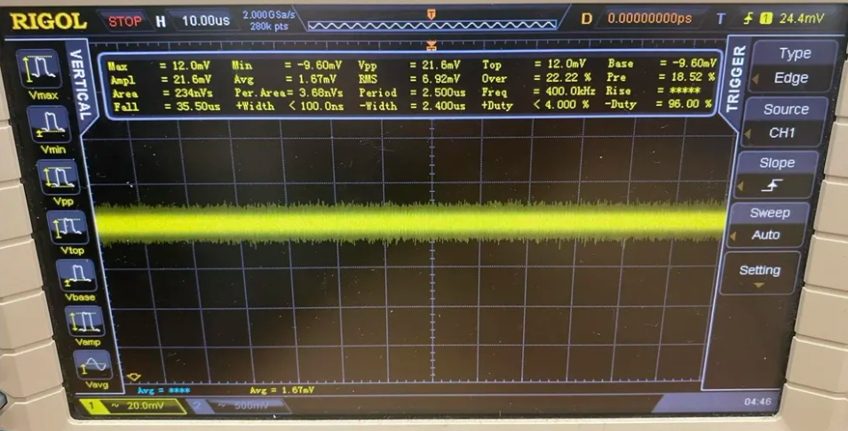
Figure 5: 1kΩ Linear Regulator AC Coupling Oscilloscope
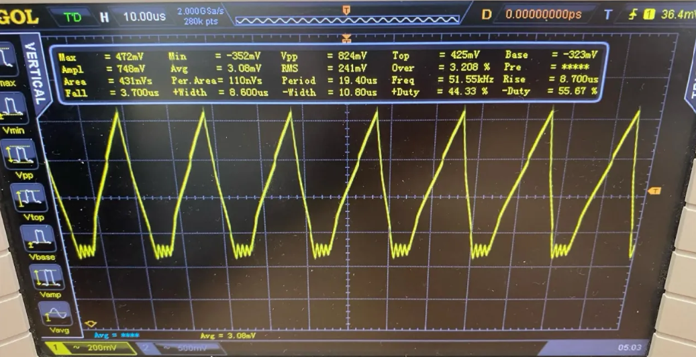
Figure 6: 47Ω Switching Regulator AC Coupling Oscilloscope
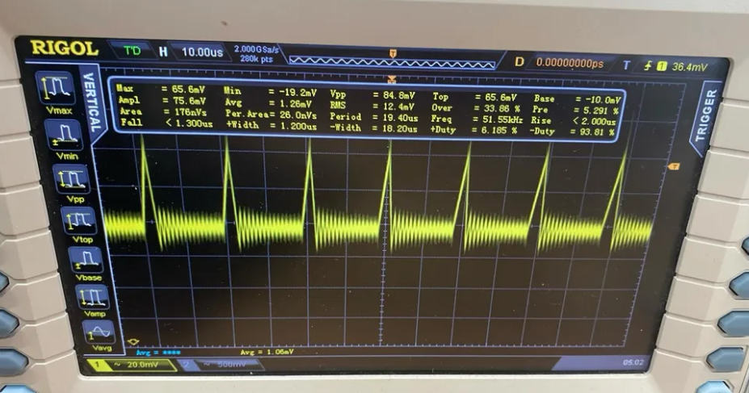
Figure 7: 1kΩ Switching Regulator AC Coupling Oscilloscope
From our data, we find that there are some discrepancies, first we find that the voltage outputs are not the ideal output of the chip’s internals. This is likely due to non-idealities of the chip as it is exposed to heat and internal references are slightly altered, and potential inductance interference from the length of wires connecting components (Gemini/GPT.)

We also read that we can have significant noise, as mentioned above this is contributed to by the inductance of our wires, as tested when using shorter wires we experience less noise comparatively to the longer wires.

Per our results, we can see that both regulators are within spec for voltage and possible slightly without of range of spec for the current, this is likely due to the resistor being 47 ohm rather than 50 ohm. Particularly, both are better with the lower loads, with the switching regulator being better for higher loads and the linear typically being better for lower loads (due to a fixed input current requirement for the switching vs a portion of the current being drawn/burnt.) (TI 2014), it is likely that there is some discrepancy due to wires and non-idealities of the practical assembly.

The switching regulator is much noisier, with up to over 30 times the noise Vpp, this is due to the switching operation versus a pass transistor in the linear, causing less noise introduction (TI 2014.) Noise scales inversely with load, leading to the 47Ω load switching regulator to be the noisiest.
Conclusion
In this design assignment, we find that linear regulators are very good at low loads but drop off quickly with higher loads. The switching regulator performed similarly, but likely had assembly error. The switching regulator has much more severe noise due to active switching of internal transistors. To design these circuits, we learnt about Zener diodes non-linearity to prevent electrostatic discharge, and the use-case of capacitors and inductors in regulating circuitry, along with full-bridge rectifiers to convert AC to DC.

This assignment reinforced the emphasis on regulators being an integral part of power architecture of electronics, and introduced us to their applications and how to simulate them from the source power down-stream, emphasizing our usage of LTSpice and RIGOL electronics oscilloscopes, power supplies, waveform generators, and miscellaneous tools.

References
- Texas Instruments. (2014). Linear versus Switching Regulators in Industrial Applications with a 24-V Bus (Application Report SLYT527). Texas Instruments. https://www.ti.com/lit/pdf/slyt527
- Texas Instruments. (2026). Zener Diodes Introduction (Document SLVAG00). Texas Instruments. https://www.ti.com/lit/SLVAG00
- Google Gemini and ChatGPT referenced above.

